CPE301 – SPRING 2020

MIDTERM 1

Student Name: Mateo Markovic

Student #: 2001338139

Student Email: Markom1@unlv.nevada.edu

Primary Github address: <https://github.com/mateom99/submission_da>

Directory: Midterms/Midterm1

1. **COMPONENTS LIST AND CONNECTION BLOCK DIAGRAM w/ PINS**

* Atmega328PB-Xmini w/ Atmel Studio 7.0
* Atmega328PB Debugger for Serial to USB output
* Arduino Multi-Function Shield (PB5/PB2)
* LM35 Temperature Sensor (PC4)

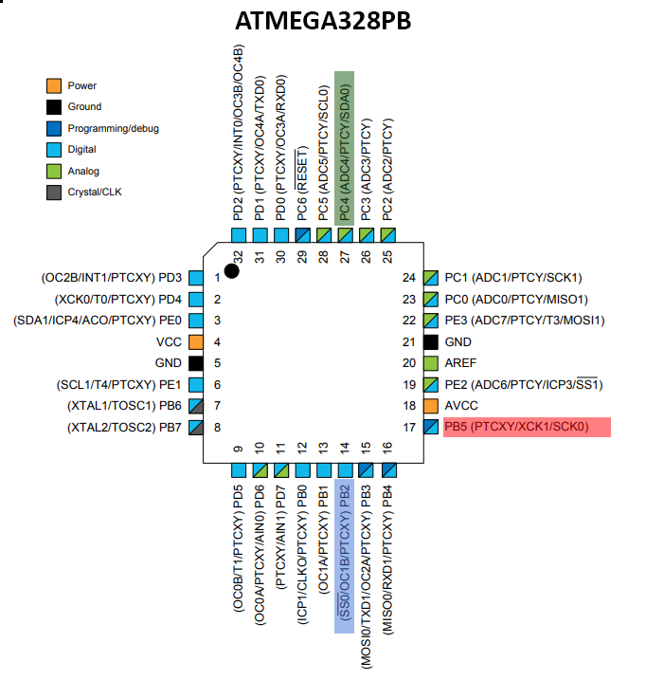

1. **INITIAL/MODIFIED/DEVELOPED CODE OF TASK 1/A**

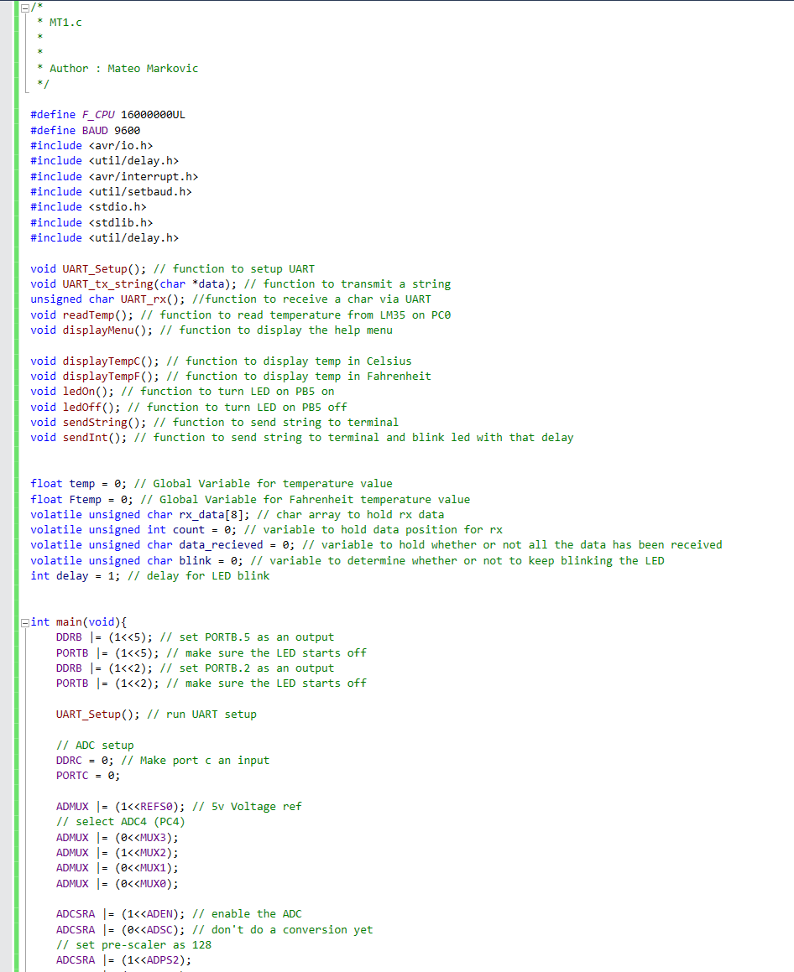

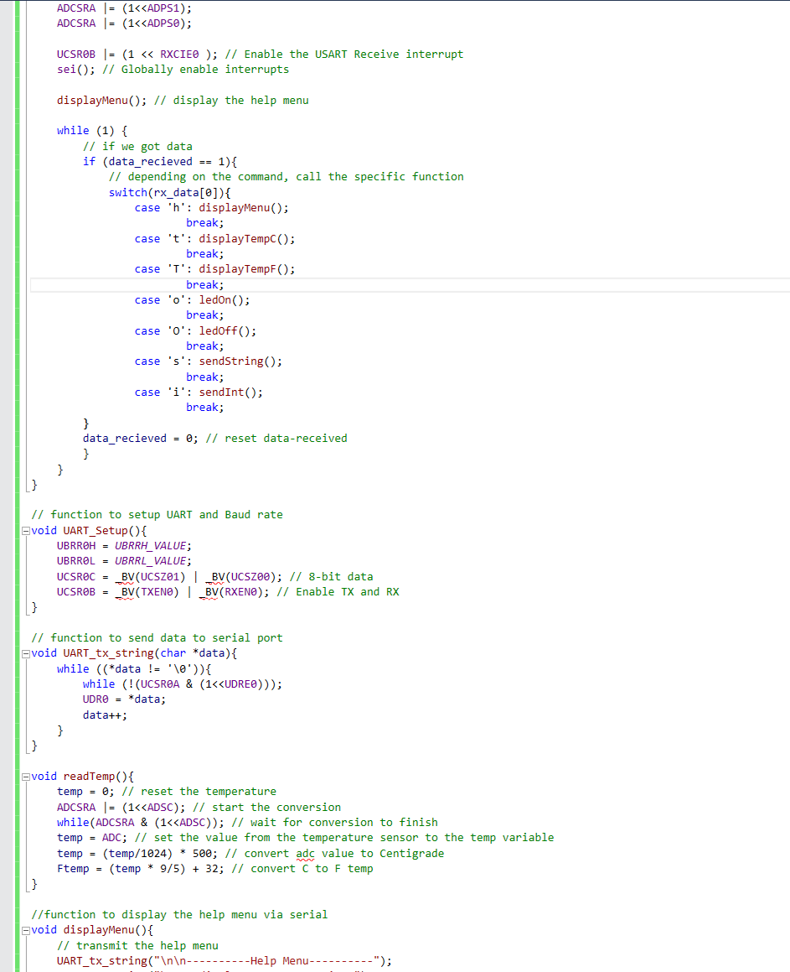

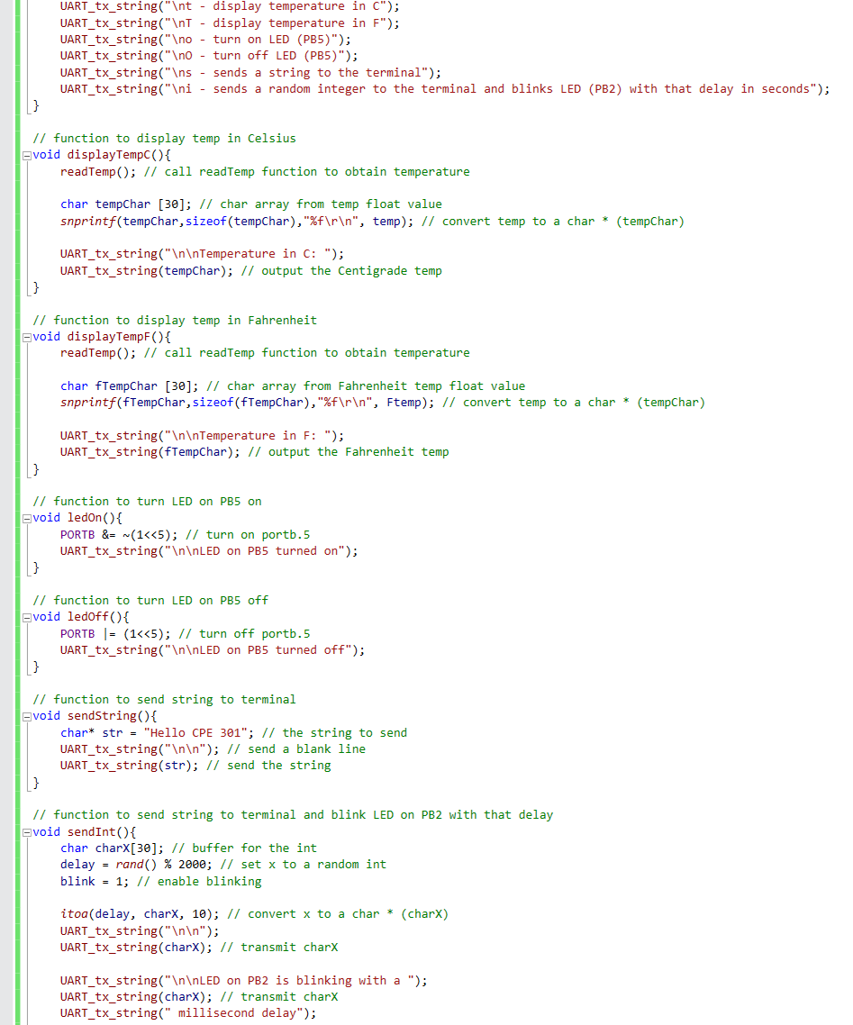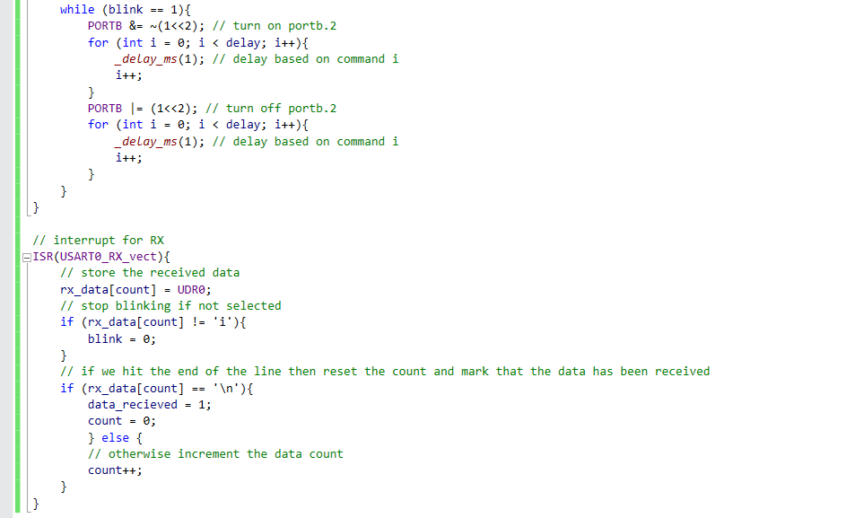

1. **SCHEMATICS**

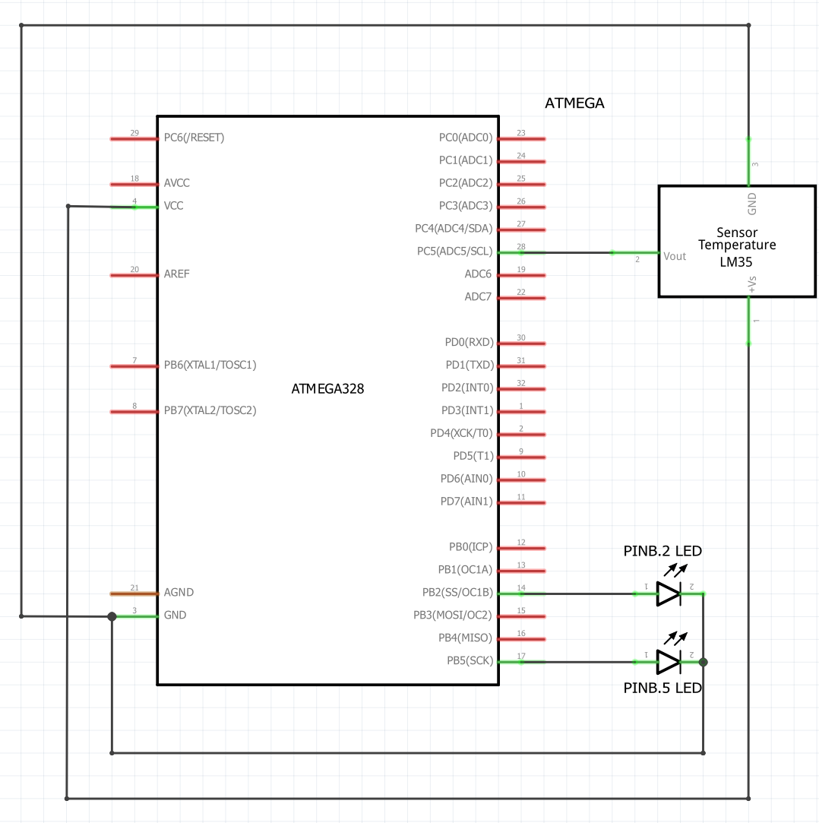

Fritzing Schematic of pins used

1. **SCREENSHOTS OF EACH TASK OUTPUT (ATMEL STUDIO OUTPUT)**

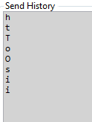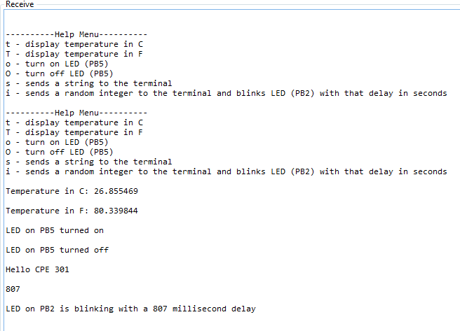

Receive Terminal + Send History

1. **SCREENSHOT OF EACH DEMO (BOARD SETUP)**

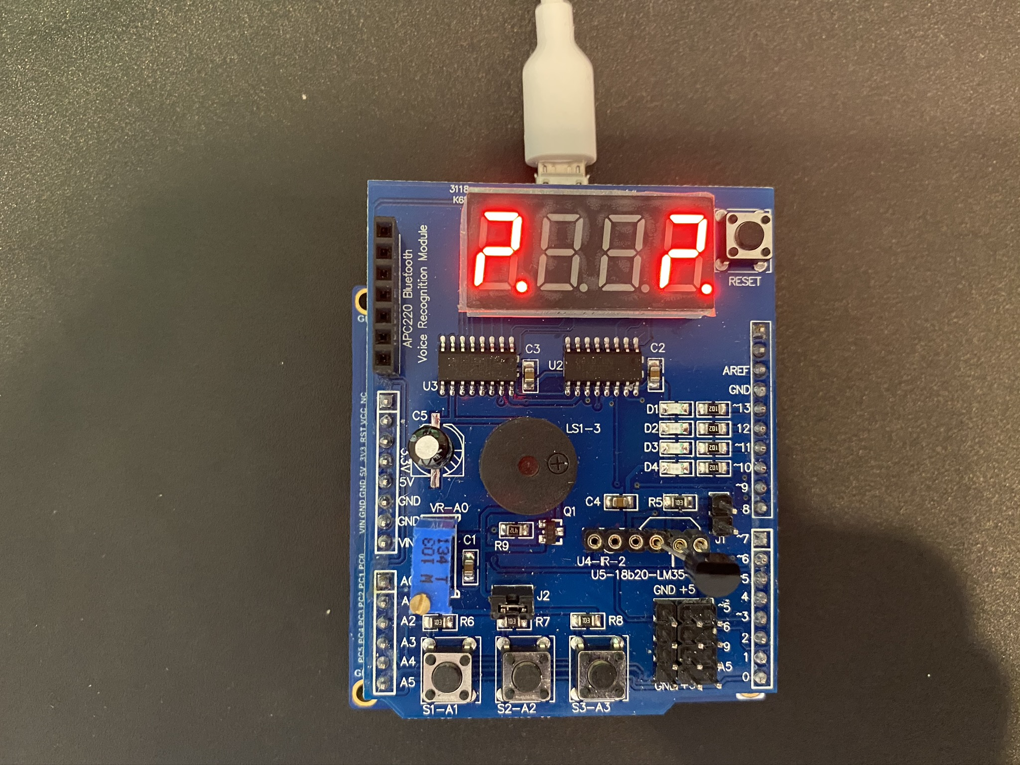

Board with multifunction shield + LM35

1. **VIDEO LINKS OF EACH DEMO**

Demonstration: <https://youtu.be/6GcVuNlFBbA>

1. **GITHUB LINK OF THIS DA**

<https://github.com/mateom99/submission_da/tree/master/Midterms/Midterm1>

**Student Academic Misconduct Policy**

<http://studentconduct.unlv.edu/misconduct/policy.html>

“This assignment submission is my own, original work”.

Mateo Markovic